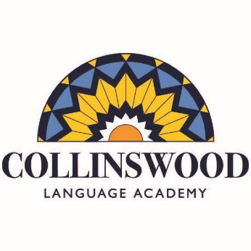

Collinswood Language Academy
4000 Applegate Road
Charlotte, NC 28209
980-343-5820

May 15, 2019

Respected community members, friends, and families:
Collinswood Language Academy is a CMS magnet school that serves K-8 children.

Each year our school hosts a summer reading program to encourage our students to read. The academic research is clear - students who do not read during the summer fall behind in school. This “summer slide” is cumulative; non-reading students do not catch up. We look to families, community members and businesses like yours to partner with us in encouraging reading, to continue our academic excellence during the summer.

Please consider partnering with us. Your monetary donation funds the program, including the celebration and Summer Reading shirts, which we have found are a huge incentive to the students to read. Prizes for the participants are also greatly appreciated. In exchange for your donation, we will include your business on a school-wide distribution thanking you for your donation. Sponsors of $500 or more will have their logo appear on the back of the t-shirts that students wear each week.
Thank you in advance for your community partnership with our Summer Reading Program. Your contribution helps give our students the opportunity to improve their reading proficiency and to prepare them for school.

Respectfully,

Stacy Holliday
Chair -Summer Reading
sjhollid4234@gmail.com

For your tax records, please use our EIN: 56-1557697

